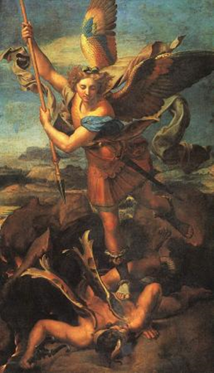
BULLETIN: If you have news for the bulletin, please call the Rectory 402-729-2058 or email st.michael.fairbury@gmail.com. Deadline for additions -Wednesday by 9:00 AM.
ADOPT A PRIEST: Our Deanery is taking part in the "Adopt a Priest" program. St. Michael's has adopted Fr. Leo Seiker; Please pray for him.

St. Michael's / St. Mary's
FR. JOHN B. BIRKEL, PASTOR

Cell Phone: (308) 991-6893 Office Phone (402) 729-2058
Email: frbirkl@hotmail.com www.stmichaelsfairbury.org

St. Michael's PO Box 406, Fairbury, NE 68352
St. Mary's 5th & Amanda Streets, Alexandria, NE

Confession schedule: Saturday 4:45 PM to 5:15 PM
25th Sunday of Ordinary Time September 24, 2023

St. Michael's and St. Mary's Parishes would like to extend a warm welcome to all who are visiting us or are new to the area. If you are not currently registered at St. Michael's or St. Mary's and consider this your Parish, please call the Rectory at (402) 729-2058.
St. Mary’s Parish Council: Ritchie Burkhart Trustees: Bob VanWesten and Bob Bachle
St. Michael’s Parish Council, LeAnn Krause, and Mary Prellwitz. Georgann Friedrichsen, Daryl Banahan, Gina Gifford
Trustees: Chris Goeking and Randy Prellwitz
St. Michael’s PCCW: Vickie Banahan CCD Coordinator: Georgann Friedrichsen
St. Mary’s PCCW: Deb Vanwesten Knights of Columbus: Randy Prellwitz
Parish collection data: September 17, 2023 |  |  | Debt Reduction  Loan Total as of Today  AMOUNT TOWARDS DECEMBER 2023 PAYMENT  Due Dec. 31, 2023  AMOUNT TOWARDS DECEMBER 2023 PAYMENT  To be collected throughout the year |  | Loan Payment  $17,360.36  $10,400.39
Adult  Loose Plate  Online Giving | $941.00  215.07  115.00 | $550.00  115.00
Children  Building  Cemetery  Holy Day  Mission Coop | 15.00  35.00 | 30.00 |  |  | $17,360.36  -$10,400.39  $6,932.97
Debt Reduction | 100.00 |  | PARISH FINANCIAL INFORMATION
Total | $1,451.07 | $695.00 | Operation Cost per week |  | $2,039.84
 |  |  | This Week’s Collection |  | $1,316.07
 |  |  |  | Shortage |  | $723.77

Mass Intentions for Sept. 25th – Oct. 1st
Monday | No Mass | No Mass
Tuesday | 9:00am | Fr. Paul Quinter
Wednesday | Noon | Maureen Neville+
Thursday | 9:00am  Cedarwood | Special Intention
Friday | 5:30pm | Special Intention of Genie Cuba
Saturday | 9:00am  5:30pm | Alexandria: Special Intention  Leonard Stoltzer
Sunday | 8:00am  10:00am  Noon | For the people of the parishes  Special Intention of G.G.  Spanish Noon Mass
St. Mary’s Church Cleaning for September
Peggy Niederklein

St Michael’s has a daily Mass chapel. It is accessed through doors on the west end of the church.

PLEASE PRAY FOR:
Send requests to
St.michael.fairbury@gmail.com

THOUGHT OF THE WEEK
May we never risk the life of our souls by being resentful or by bearing grudges.
-Saint Gregory of Nyssa, bishop
PRAY FOR VOCATIONS
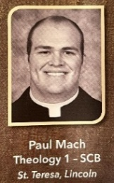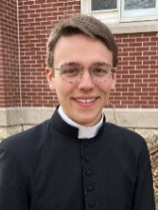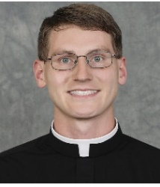
PAUL MACH is the son of Keith & Mary Mach of St. Teresa Parish in Lincoln, NE. He is in second Theology at St Charles Borromeo seminary in Philadelphia.
MATTHEW DAVIS is the son of Joachim & Vicki Davis. He is in his third year (of 7) at Our Lady of Guadalupe seminary in Denton.
THOMAS MATYA is the son of John & Lisa Matya of St. Charles Borromeo Parish in Omaha.
MAX SUMMA is the son of John & Cathy Summa of St. Vincent DePaul in Seward, NE. He is in the Propaedeutic Stage at St. Gregory the Great Seminary.
SR. MARY CHIARA of Gretna, NE who is in her 1st Vows with the School Sisters of Christ the King of the Diocese of Lincoln.

FINANCIAL STATEMENTS for year end 2022-2023 Can be found in the back of the church or online at https://stmichaelsfairbury.org/bulletin/.

Please join us for Thursday Mass at Cedarwood 9:00am.

CCD No CCD Wednesday September 27, 2023. Welcome to Kelli Kokoruda as our new 3-4th grade teacher. Thank you so much for joining our team.

PCCW will be conducting a Diaper Drive during the month of October. A bassinet will be located in the back of church for your donation. Sizes 5 and 6 are in the greatest demand. Monetary donations are also accepted. Put your donation in an envelope marked “Diaper Drive” in the Saturday or Sunday collection. Thank you.

Join the Bishops of Nebraska at the Pro-Life Banquet and Conference on Oct. 6th and 7th. Visit necatholic.org to register by October 1st before it’s too late!
RED CROSS BLOODMOBILE Tuesday, October 10th from 11:30am – 5:15pm at the Fairbury Elks Lodge – 525 G St. For appointment call 402-300-1767.
Opportunity Scholarships Empower Parents and Students: See www.lincolndiocese.org/opportunity for more details.
"Come away to a quiet place and rest awhile" Our Lady of Good Counsel Retreat House, Waverly upcoming retreat. "Rekindling Eucharistic Amazement" with Fr. Wade Menezes, CPM on Sept. 30-Oct. 1. Read more and register at www.goodcounselretreat.org, email office@goodcounselretreat.org or call 402-786-2705.
Relic of St. Jude (the Apostle of the Impossible) will be touring the U.S. and making four stops in Nebraska. This is an amazing opportunity for healing as the arm of St. Jude, patron saint of impossible causes, travels through the U.S. from its original place of dwelling in Italy. For more information visit spiritcatholicradio.com/jude
Sept. 27 – St. Michael Catholic Church, Lincoln – Veneration 4pm to 10pm – Mass at 6pm
Sept. 28 – St. John Vianney Catholic Church, Omaha – Veneration 1pm to 10pm – Mass at 6pm
Sept. 29 – St. Leo the Great Catholic Church, Omaha – Veneration 1pm to 10pm – Mass at 6pm
Sept. 30 – St. Patrick Catholic Church, Fremont – Veneration 1pm to 10pm – Mass at 12pm, Noon

